
Absolute Accuracy Inc.
2451 Riverside Drive, Los Angeles CA 90039
Ph 323 662 9237 Fax 323 662 0904
Email bbrp@aol.com Web www.absoluteaccuracy.net

Instructions for Model 3100
Chart Reader.
.

- Install the driver software for the Model 3100.
Remove CD from box and insert into Drive. Open Windows Explorer window to view contents of the CD. Open the Drivers directory and then open the appropriate directory for your computer, either 32bit or 64bit. If you are not sure which to choose, open the control panel from the windows start menu and choose System. The operating system you have will be listed under system type. Double click on the exe file and follow the instructions on the setup screens. Most new Computers are 64bit.

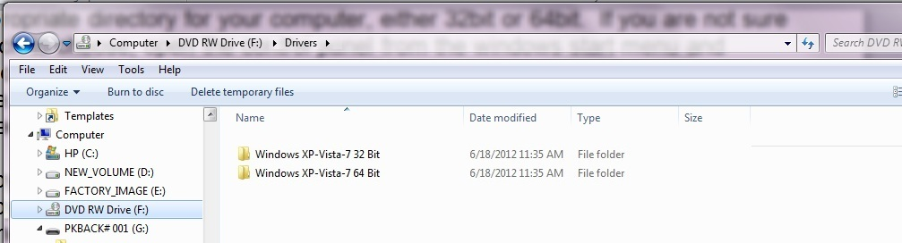

- Copy files onto the computer’s hard drive “C”.
Copy the entire directory A3100 on to the C:\\ Drive. There four files critical to the operation of the 3100, ReadChart7.exe and ReadChart24, chartdata.txt and one of the AAI3100.xls in the English 570 directory. Do not change the name of the exe or txt files or try to use them in a different directory as they are location dependent and will not work in other drives or directories. If something happens to the files in the A3100 directory, you can recopy them from the CD. You must have a version of Microsoft Excel in order to operate the xls program. Open the file in Windows Excel (tested on Office 1997 2000, 2003, 2007, 2010, 2013). If you have Excel 2010 you may wish to open the AAI3100-xxx.xls file and save as macro enabled xlsm file. Make sure macros are enabled on your Excel program.
Note, Tested on 2016 Excel and works well.

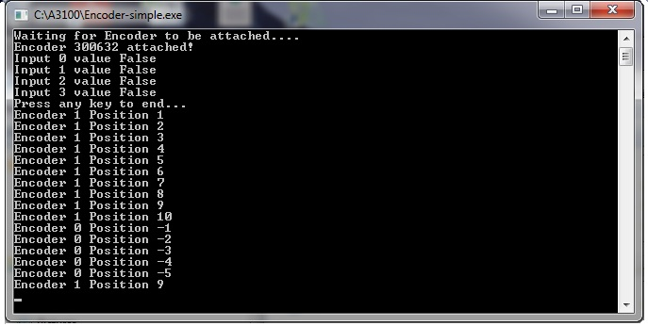

- Setting up and testing the 3100.
Remove instrument from box. On a flat table or desk next to PC or Laptop, plug the USB cable from the instrument to the PC. Place the chart on the center of the platter shaft and secure the chart to the platter with centering guide. The first time you plug in the USB cable into the PC there may be a few moments to install the driver software and register the 3100. (You may wish to test the ReadChart.exe file in the A3100 directory before opening up the Excel program. If the drivers have been installed correctly, and you double click on the ReadChart7.exe or ReadChart24, a dialog box will open. If the USB is not yet connected it will say waiting to be attached. If USB is attached there will be a serial number and some other data displayed. Rotate the chart anticlockwise and notice the dialog box will add a line for every position change of either the platter (0) or arm (1). The dialog box will record lines until the platter (0) position reaches 192(24Hr) or 500 (7Day) and will stop and say ok at the bottom. Press the enter button and the dialog box will close and the chartdata.txt file will be written to the c:\A3100 directory.

Note: If you start the ReadChart program from the Excel menu for the first time you might see there is a reading stored in the memory.

If this is true…. Close the window
And press Read Chart Button Again
It should only happen once when first opened.
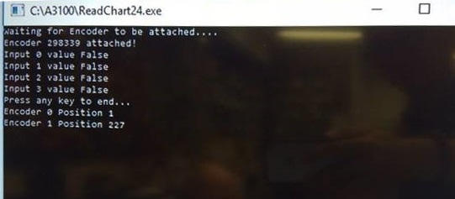

Correct. Proceed to read the chart.
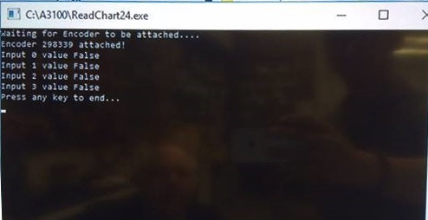

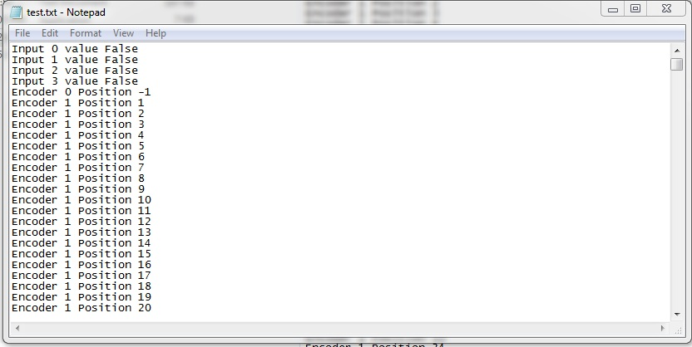

Open the chartdata.txt file and see if the data lines are recorded in the file. If the ReadChart.exe file is opened again, the chartdata.txt file will be overwritten.

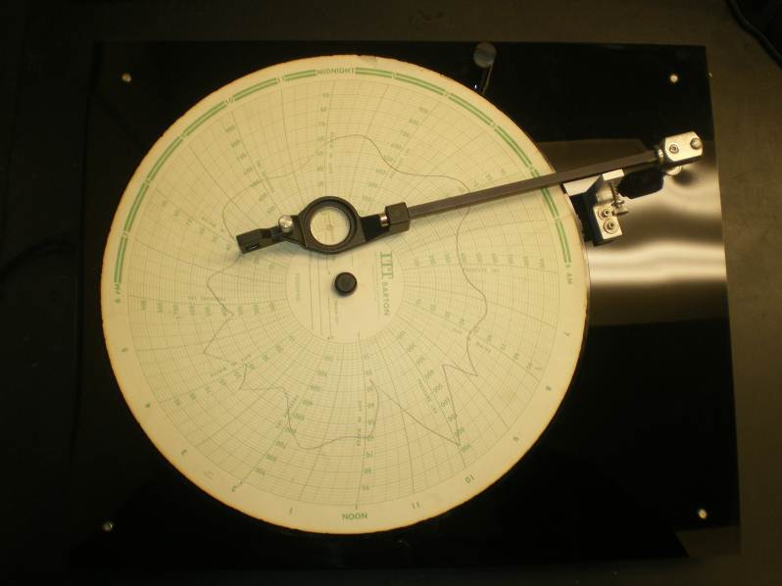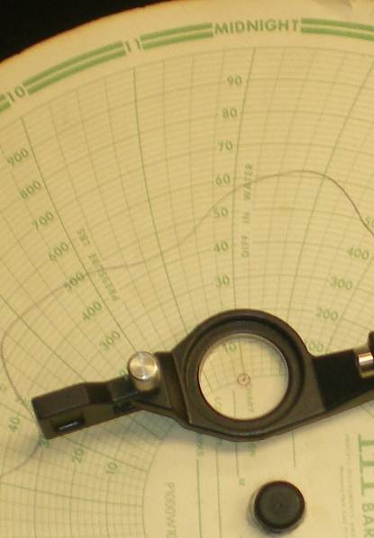

- Record a chart.
Open the Excel Spreadsheet C:\570 English xxx\AAI3100xxx.xls. Start with the single line Excel file to familiarize yourself with the measuring procedure. Which ever you choose 24 Hour or 7 Day, be sure to set the switch on the 3100 to the appropriate setting. The spreadsheet must be set to allow macros. Open Excel go to File/Options/Trust Center/Trusted Locations and put C:\A3100\ in the Allowed Paths. Upon opening the chart data screen will be open with a menu that controls the operation. If you close the menu you can re-open by pressing the Ctrl and Z keys at the same time. If you do not want to change the settings you can run Macro1 from the Macros menu. The first button on the top is the clear the chart. If there is a previous recording in the chart, you can clear the chart. The Excel file is a custom file based on the chart you use.

The program is designed so that you can complete the operation of recording the chart without the need to enter anything on the spreadsheet. The txt file will retain the measurement data until the Read the Chart button is pressed. Whether you read new data in or reprocess old data remember to press the Clear Report Data button.
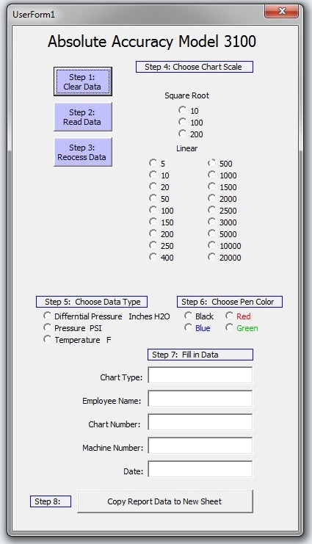

Note: For specific steps for dual line static and differential pressure procedure, go to instructions tab inside the appropriate excel program.

Easy Steps:
- Clear report Data
- Zero Set Arm and Set Platter to 24/00 and push Read Data Button. Complete Rotation of the chart to read the data.
- Once data from the chart has been read, push enter to exit the screen and push the Process Data Button.
- Choose Chart Scale from the Square Root or Linear selections. Chart will fill up.
- Choose Data Type
- Choose Line Color
- Fill in the information about the chart
- Copy the data to a new Sheet and repeat process for all the lines on the chart.
*Note If you choose the wrong chart type you can from the menu, clear the data (step 1) and process the data again (Step 3) and then choose correct chart type (Step 4).

- Position the chart onto the platter and set the reticule in the arm to the zero line (towards the center of platter) of the chart while setting the time position of the chart to the 12:00 A.M. Position. Note: You can use the dial on the arm stop to set zero position. (If using a 7 day chart set to Sunday 12AM)

- Check again that you are in zero position and 12:00AM. Activate the Read the Chart button to begin measuring operation. (It is possible for a couple of lines of data to appear below the header lines of the readchart window. If there is, close the window and press the button again and this will start fresh with no lines of data.

- Move the reticule on the arm up to where the line is recorded on the chart. The lines on the dialog window should advance as the arm moves up. Now move the platter anti-clockwise and follow the line with reticule moving the arm up and down as you turn the platter. If there are periods of time where there are no measurements, move arm to zero position during that area on the chart. You still must complete a revolution of the chart. Note the average will also average the zero values on the chart. If you do not wish to have an average with the zero values, you can manually average the cells with the data you select.

- After complete rotation, and all of the chart values are recorded into the dialog box. The dialog box will stop recording when the platter (0) reaches 192(24hr) or 500(7Day) closing. Press the enter key to close the dialog box. Next press the Process Data button (Step 3). The spreadsheet screen fills with the data from the chart. Partial reading of the chart is possible if you make sure to have reticule arm resting at zero until reading starts as you turn chart. Next choose either a square root or linear scale to apply to the recorded information. The values will now appear in the time grid and average, min and max values are recorded.

- The rest of the steps in the box fill in your information and do not have any effect on calculations.

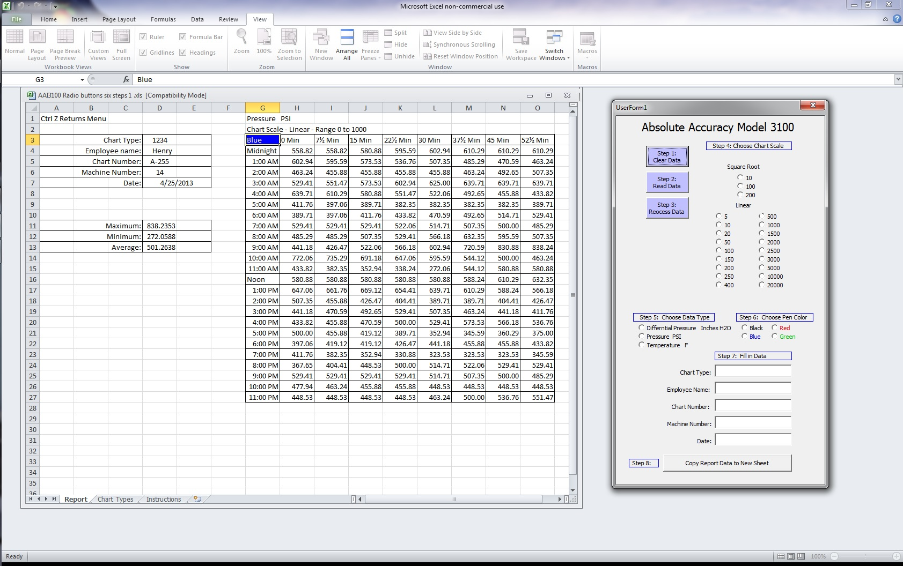

- Analyze your results.
You can then fill in the appropriate boxes with information about your chart. Average values from all of the chart readings will be available on the different sheets stored in this file. You can delete them or copy them to a different file if desired.

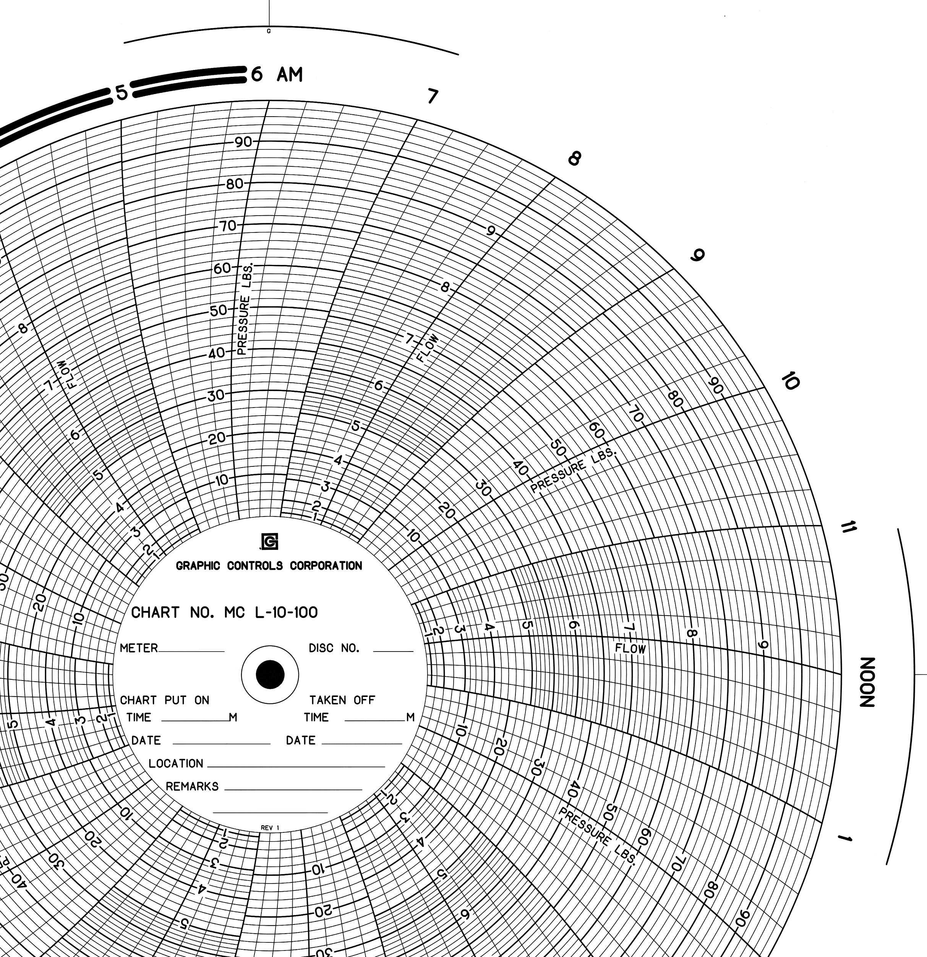

- Types of charts.
There are two basic types of recording charts, linear and square root scaled.
Some charts have both scales on one chart. The basic difference between linear and square root scale is that linear evenly divides the scale from top to bottom with equal increments. The square root scale starts off with small increments at the bottom of the scale and exponentially increases the distance between graduations at the top of the scale. The purpose of this is to increase the accuracy by giving more of the measuring range where the activity is taking place. There are a variety of ranges for the scale or sometimes there is a percentage scale. ‘The formula in the spreadsheet program is based on the chart you use.

The information provided and results derived are for information purposes only. Absolute Accuracy and its associates assume no liability for any decision or consequence of any action based on any results or information provided from this device or software.

Rev 5 042513

