Absolute Accuracy Inc.

2451 Riverside Drive, Los Angeles CA 90039

Ph 323 662 9237 Fax 323 662 0904

Email [bbrp@aol.com](mailto:bbrp@aol.com) Web www.absoluteaccuracy.net

Possible newer driver is not compatible with operating files.

Check to see what version is installed.

Go to Windows settings and Apps & Features

Phidgets21 Libraries should be 3.1.215 if not Uninstall and Install the driver from the link.

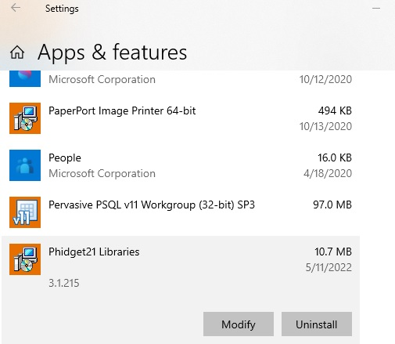

After install the version will be 3.1.215

Hidden Icons tab in the Windows Bar should have a Ph, It may not show so test the Readchart7 to see if the planimeter is writing to the txt file.

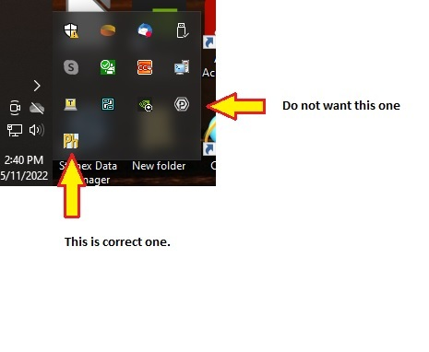

With 3100 plugged into USB and light is on, click on C:\A3100 ReadChart7.

Should look like this.

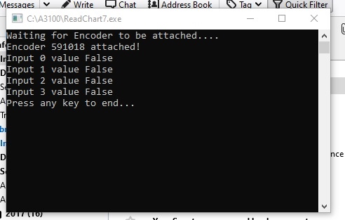

After moving platter or arm, will look like this

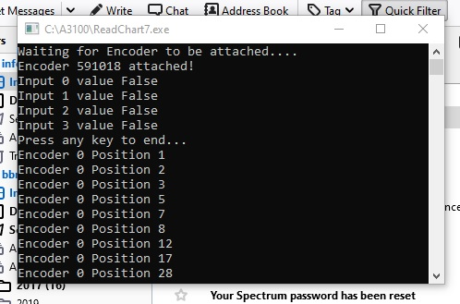

Press return to close this window. Don’t type characters in the window as it makes the txt file blank.

Now click on the C:\A3100 ChartData.txt file and see that the same information is in the file.

Every time the ReadChart file is run the txt file is replaced.

Robert