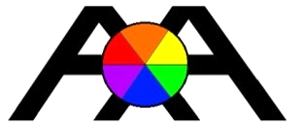

Absolute Accuracy Inc.

2451 Riverside Drive, Los Angeles CA 90039

Ph 323 662 9237 Fax 323 662 0904

Email [info@aaisurvey.com](mailto:info@aaisurvey.com) Web [www.aaisurvey.com](http://www.aaisurvey.com/)

Certificate of Conformance

We certify that all material/parts, and or assemblies shipped herewith

Conform to specifications and associated documents, as referenced on

the purchase order referenced below. The unit will comply with specifications and test results as established by our quality management system. All merchandise is brand new and free from all defects.

Company Name: ____PT. Rekajasa Asyatama _____

P.O. Number:/Invoice Number: ____Inv# 106357

Model and Sn Number: _AAI 3100 sn# 20079, 20080________

Signature: 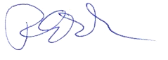Robert Poplar, President Date: 10/30/2019