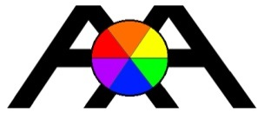
Absolute Accuracy Inc.
2451 Riverside Drive, Los Angeles CA 90039
Ph 323 662 9237 Fax 323 662 0904
Email bbrp@aol.com Web www.aaisurvey.com

Certificate of Conformance

We certify that all material/parts, and or assemblies shipped herewith
Conform to specifications and associated documents, as referenced on
the purchase order referenced below. The unit will comply with specifications and test results as established by our quality management system.

Company Name; ____PAKISTAN OILFIELDS LTD __________

P.O. Number; ________PSO-00834/MEYAL_______________

Model and Sn Number; _3100 - sn#1 0037 ________________

Signature;___________ 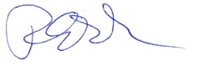___________ Robert Poplar Date: 10/23/2014

